The Routledge Encyclopedia of Modernism

**Etkin, Mariano (Josué) (1943)**

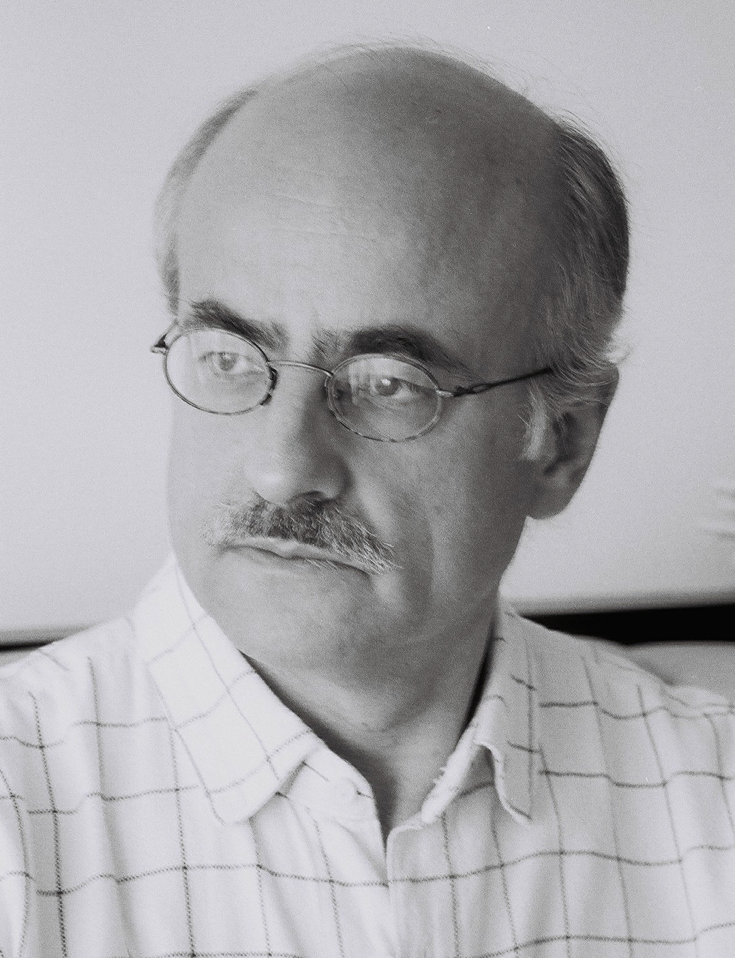 Photo: Maria Cecilia Villanueva

Mariano Etkin is an Argentinean composer, which is among the most important Latin-American composers of the second half of the twentieth century. He received his main musical education in his hometown, Buenos Aires, and continued his studies in the United States and Europe. Both, his musical creation as his theoretical production are a benchmark for composers and researchers. By exploring perception thresholds, Etkin’s works unfold between real and apparent in a profuse and ambiguous sound world. His writings address the study of musical works and issues around music creation.

**Timeline of Life**

1943 1959 1965 1968 1971 Currently

| | | | | |

Born First work premiere Joined at CLAEM Studied in Europe Returned to Argentina Teaches and composes

**Musical studies and career**

Etkin started his training from a rich family musical environment and at the Williams Conservatory of Buenos Aires. The reading of Juan Carlos Paz’s *Introduction to the music of our time* (*Introducción a la música de nuestro tiempo*, 1955) prompted him to look for other ways and began studying piano and music theory with Ernesto Epstein. Subsequently continued his composition studies under the guidance of Guillermo Graetzer. Etkin joined the group of composers around the *Agrupación Euphonia* (then *Agrupación Música Viva*), formed mainly by Gerardo Gandini, Antonio Tauriello, Armando Krieger and Alcides Lanza. Together with this group of young composers, Etkin explored through the creation of international trends in vogue during the '50s. His first public premiere was *Three Pieces* for Piano (1959). Between 1965 and 1966, Etkin participated as a fellow in the Latin American Centre for Advanced Musical Studies (CLAEM) of the Instituto Torcuato Di Tella (Buenos Aires). There, he studied with Alberto Ginastera Etkin, Gerardo Gandini, Maurice Le Roux, Iannis Xenakis, Earle Brown and Mario Davidovsky, among others. Between 1968 and 1970, he won the Dutch government grants and the Organization of American States (OAS) to study, respectively, Conducting at the Utrecht Conservatory with Paul Hupperts and composition at the Juilliard School of Music in New York with Luciano Berio. In the Music Academy of Basel, Switzerland, he completed a course of direction and interpretation of twentieth century music with Pierre Boulez. In 1971, the CLAEM awarded him a second scholarship for composition.

Etkin has spread his musical thinking through various articles, lectures and their extensive teaching. The writings, published mostly in *Dérives* (Montréal), *Revista del Instituto Superior de Música* (Santa Fe), *Música e Investigación* (Buenos Aires), *Revista Arte e Investigación* (La Plata) and other compilations, addresses some of the problems on the composition of most interest to Etkin: perceptual thresholds on the length and height of sound, identity issues, treatment of musical form and sound material.

Etkin was a professor at the National University of Tucuman, Rio Cuarto and Litoral (Argentina), at McGill University and Wilfrid Laurier University (Canada). Currently, he teaches at the Faculty of Fine Arts of the National University of La Plata.

**Production and characteristics of the works**

Most of the work of Etkin is instrumental. Although not usually resort to the use of the human voice, his works are often linked to texts or extra-musical elements. Thus, the composer gives multiple meanings to their works. While Etkin's music is not discursive, because from the formal point of view there are not thematic exhibitions or developments of motives, it is full of poetic-dramatic elements. Some titles of works suggest places, moments or situations of life and, in turn, it refers to the type of procedure or material Etkin explores each one of them. Precisely, Etkin based their works on a selection and processing of sound material rather than the type of relationship between the sounds. Thus, he produces what he calls a "Material music". To a large degree, Etkin's works have micro-variation process of sound material. These small changes may be related to the duration or the spectrum of harmonics of sounds. His works received awards in Argentina: Fondo Nacional de las Artes and Municipalidad de Buenos Aires, in the Netherlands: Gaudeamus Foundation and Switzerland: Sixth International Composers Seminar Boswil.

**Chronological list of works (\*** Publisher: [Thuermchen Verlag](http://www.thuermchen.de/VERLAG/start.html))

|  |  |  |
| --- | --- | --- |
| **Work** | **Year** | **Instrumentation** |
| *Tres piezas* | 1959 | Piano |
| *Variantes* | 1960 | Flute |
| *Planos, música para una pintura de Eduardo Mac Entyre* | 1960 | Piano |
| *Quinteto aleatorio* | 1961 | Wind quintet |
| *Tres parábolas* | 1963 | Chamber ensemble |
| *Elipses* | 1964 | String orchestra |
| *Entropías* | 1965 | 2 horns, trumpet, 2 trombones and tuba |
| *Estáticamóvil I* | 1966 | 2 trombones, harpsichord, harmonium, 2 percussionists and 3 double basses |
| *Estáticamóvil II* | 1966 | Violin, Viola and Violoncello |
| *Homenaje a Filifor forrado de niño* | 1966 | 2 flutes, 2 clarinets and percussion |
| *Soles* | 1967 | Flute, horn and double bass |
| *Distancias* | 1968 | Piano (Publisher: Ricordi Americana) |
| *Interludios* | 1969 | Piano |
| *Juego uno* | 1969 | 2 Trombones |
| *Muriendo entonces* | 1969 | Horn, trombone, tuba, 2 percussionists, amplified viola and amplified double bass |
| *IRT-BMT* | 1970 | Flute and double bass |
| *Copla* | 1971 | Flute, clarinet, bassoon and horn. |
| *Dividido dos* | 1971 | Amplified accordion and tape |
| *Música ritual* | 1974 | Symphony orchestra |
| *Otros soles\** | 1976 | Bass clarinet, trombone and viola |
| *Umbrales* | 1976 | Flute and alto flute |
| *Lo uno y lo otro* | 1977 | Piano |
| *Otros tiempos* | 1978 | String quintet or string orchestra (rev. 1981) |
| *Paisaje* | 1979 | String orchestra |
| *Aquello\** | 1982 | 2 Pianos |
| *Frente a frente* | 1983 | Flute, clarinet, voice, percussion and double bass |
| *Caminos de cornisa\** | 1985 | Flute, clarinet, piano and percussion |
| *Resplandores sombras\** | 1986 | Symphonic orchestra |
| *Recóndita armonía\** | 1987 | Viola, violoncello and double bass |
| *Arenas (to the memory of Morton Feldman)\** | 1988 | Piano. |
| *Caminos de Caminos\** | 1989 | Alto flute, bass clarinet, voice, piano and viola. |
| *Locus solus\** | 1989 | 2 Percussionists |
| *Perpetual tango (version of John Cage’s work)* | 1989 | Piano |
| *Trío* | 1991 | Trumpet, trombone and tuba |
| *Abgesang Mambo\** | 1992 | Flute/alto flute/bass flute, oboe/English horn, clarinet/bass clarinet, bassoon, horn, trumpet, trombone and double bass |
| *Cifuncho\** | 1992 | Violin |
| *Taltal\** | 1993 | 4 Percussionists |
| *La sangre del cuerpo\** | 1997 | Trombone tenor-bass/Alto trombone, percussion, piano, violoncello, double bass |
| *de la indiferencia\** | 1998 | Bass Clarinet, trombone, percussion, violin and violoncello |
| *Lo que nos va dejando\** | 1998 | Percussion solo |
| *Sotobosque\** | 1999 | Horn, Flugelhorn sopr. Sib, trombone contralto, tuba, 2 percussionist |
| *La naturaleza de las cosas\** | 2001 | Clarinet, trombone tenor-bass, violoncello and piano |
| *Pobres triunfos pasajeros\** | 2002 | Piano |
| *Trío* | 2003 | 3 percussionists |
| *Cinco poemas de Samuel Beckett* | 2005 | Bass clarinet, trombone, percussion, violin, violoncello and reciter |
| *Estuche de lágrimas* | 2006 | Guitar |
| *Flores blancas* | 2006 | Clarinet, bassoon, trombone, percussion, piano, violoncello and double bass |
| *Lamento por James Avery* | 2009 | 2 violins, violoncello and double bass |
| *Primer estudio para lágrimas* | 2009 | Clarinet, horn and violoncello |
| *Segundo estudio para lágrimas* | 2009 | Clarinet, horn and violoncello |
| *Composition 2010 No. 1a (Richard, La Monte y Arnold en Solitude)* | 2010 | 2 mezzo-sopranos, 2 contraltos, 2 baritones and 2 bass |
| *Composition 2010 No. 1b (Richard, La Monte y Arnold en Solitude)* | 2010 | 2 sopranos, mezzosoprano, countertenor or baritone and bass |
| *Tercer estudio para lágrimas* | 2010 | Horn and double bass |
| *Alte Steige* | 2012 | Clarinet, trumpet and trombone |

**Incidental Music**

|  |
| --- |
| **Music for Theatre** |
| *Les Patients* by Jacques Audiberti. |
| *L'armoire classique* by Jacques Audiberti. |
| *El señor fulano* by Ricardo Massa. |
| *En alta mar* by Slawomir Mrozek. |
| *La reconstrucción de la Opera de Viena* by Mario Trejo. |
| La gallina radioactiva by Rolando Malié. |
| *Esa canción es un pájaro lastimado* by Alberto Adellach. |
| **Music for film** |
| *Los siete locos* - Director: Leopoldo Torre Nilsson, 1973. |
| **Music for dance** |
| *Los vasos comunicantes*, Bass clarinet, trombone and violoncello, 2003. |

*Hernán Gabriel Vázquez*